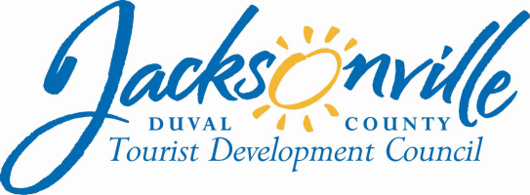
OFFICE OF THE CITY COUNCIL

Tourist Development Council
OFFICE: (904) 630-7625 |  | 117 West Duval Street, Suite 425
FAX: (904) 630-2906 |  | 4th Floor, City Hall
E-MAIL: TDC@coj.net |  | Jacksonville, FL 32202

A G E N D A

TOURIST DEVELOPMENT COUNCIL
TRAVEL POLICY COMMITTEE MEETING
Council President Aaron L. Bowman, TDC Chairman
Thursday, December 6, 2018
3:30 P.M.
117 West Duval Street
City Hall, Fourth Floor, Suite 425
Conference Room B

I. CALL TO ORDER
Roll Call
City Council President Aaron Bowman, Board Chairperson
City Council Member Lori N. Boyer, Board Member
Dawn Southworth, Board Member

Sarah Maples, TDC Administrator
Sondra Fetner, Interim TDC Staff
Kim Taylor, Assistant Council Auditor
Lawsikia Hodges, Deputy General Counsel

Meeting Convened Meeting Adjourned:
II. Introduction – Council President Aaron Bowman, TDC Chairman

- TDC Travel Policy
Public Comments
Action Item: ____

- Public Comments

- Closing Comments
- Next Regular Meeting of the TDC – January 10, 2019

- Adjourn

***Other Items may be added or deferred at discretion of the Chair. ***

